Using partitioning as most of the queries require country wise grouping.

* Create olympicdata table. (base table)

create table if not exists olympicdata

(

athlete_name string,

age int,

country string,

year int,

closing_date string,

sport string,

gold int,

silver int,

bronze int,

total_medals int

)

row format delimited

fields terminated by ',';

* Create partitioned table olympicdata_part

create table if not exists olympicdata_part

(

athlete_name string,

age int,

year int,

closing_date string,

sport string,

gold int,

silver int,

bronze int,

total_medals int

)

PARTITIONED BY (country string)

row format delimited

fields terminated by ','

STORED AS TEXTFILE;

* Load data in base table

LOAD DATA LOCAL INPATH '/home/acadgild/nikidir/olympix_data.csv' OVERWRITE INTO TABLE olympicdata;

* Load data in partitioned table from base table.

set hive.exec.dynamic.partition=true;

set hive.exec.max.dynamic.partitions.pernode=110;

insert overwrite table olympicdata_part

partition (country)

select

athlete_name ,

age ,

year ,

closing_date ,

sport ,

gold ,

silver ,

bronze ,

total_medals,country from olympicdata;

**Questions**

1. Write a Hive program to find the number of medals won by each country in swimming.

select country, SUM(total_medals) from olympicdata_part where sport='Swimming' group by country;

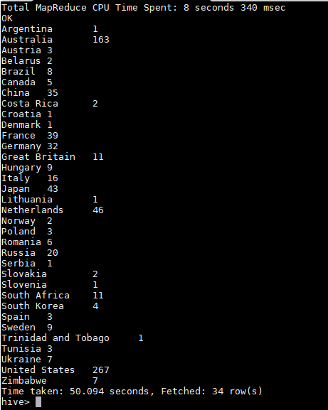

1. Write a Hive program to find the number of medals that India won year wise.

Select year, 'India',SUM(total_medals) from olympicdata_part where country='India' group by year;

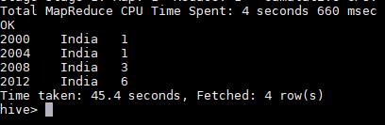

1. Write a Hive Program to find the total number of medals each country won.

Select country, SUM(total_medals) from olympicdata_part group by country;

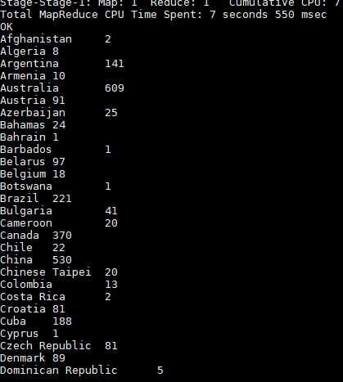

1. Write a Hive program to find the number of gold medals each country won.

Select country, SUM(gold) from olympicdata_part group by country;

